**Story split**

Smaller stories allow faster, more reliable implementation. Small stories go through the system faster, reducing variability and risk. It’s both the art and the science of incremental development.

Let’s start from the very beginning. Firstly, test your story on the INVEST model criterion. If your sprint or Kanban flow is in motion, ensure that the story size is approximately 1/10 to 1/6 of average velocity of your team. These numbers are not hard-set but more of a guideline. Hurray!! you have the right sized story.

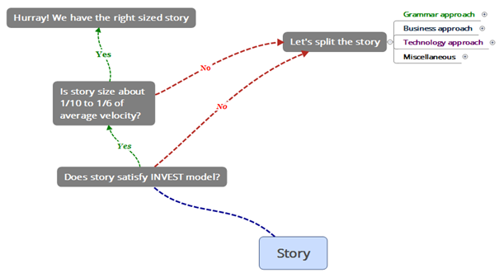

You will be using standard format of story to explore various approached to split a story

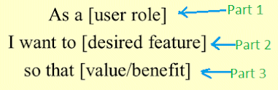

There are four approaches, you can use to split a story:

* Grammar approach
* Business approach
* Technology approach
* Miscellaneous

**Grammar approach** focus is on the grammatical construct of the story. There are

two possible paths here:

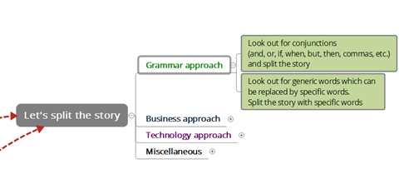

**Path 1 (Conjugations)**: In all the three parts of the story, look for conjunctions (e.g. and, or, but, when, commas, etc.). Conjunctions are potential join points for different ideas. You may like to split the story.

**Path 2 (Generic word replacement)**: You may also search for generic words (especially in Part 2 and 3) in the story which can be replaced by specific words. For example:

*As a customer,*

*I want to load the welcome page within a few seconds.*

*So that I won’t need to wait a long time for the welcome page*

In this story, you might have spotted “a few seconds” and “wait a long time” as generic words. You may now split this story in two parts:

*As a customer,*

*I want to load the welcome page within 2 seconds (if simultaneous users are less than 1000),*

*So that I won’t need to wait long for the welcome page.*

*As a customer,*

*I want to load the welcome page within 2 seconds (if simultaneous users are more than 1000 but less than 5000),*

*So that I won’t need to wait long for the welcome page.*

**Business approach** based story splitting looking for delivering smaller chunks of business value in pieces.

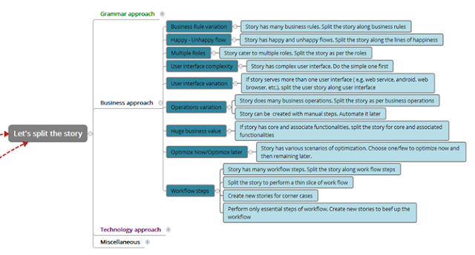

**Path 1 (Business Rule variation):** Story might have a business rule which is covering many scenarios. You can split the story along the lines of business rule variation. For example:

*As a medical practitioner,*

*I want to add the patient information to create a new patient file.*

*So, it can be accessed later.*

*And rules like:*

*1. The following information must be entered in the record of each patient: (i) First name and Last name; (ii) address; (iii) date of birth; and (iv) gender;*

*2. Data must be synced with the Mater Data Management system in real time.*

In this story, you have rightly spotted two rules. First rule talks about what data is required to be entered and second is about the data sync with MDM. Now you may now split this story along the business rules.

*As a medical practitioner,*

*I want to add the patient information to create a new patient file.*

*So that it can be accessed later.*

*And rules like:*

*1. The following information must be entered in the record of each patient: (i) First name and second name; (ii) address; (iii) date of birth; and (iv) gender;*

*As a medical practitioner,*

*I want to sync the patient information entered in above story with MDM in real time*

*So that it remains consistent across the systems.*

**Path 2 (Happy-Unhappy Flow):** A story might have a happy or an unhappy flow. You can split the story along the happy and/or unhappy lines. For example:

*As a player,*

*I want to load the latest game details if a network connection is available otherwise load only from local repository.*

*So that I can play the game irrespective of availability of a network.*

In this story if there is a happy condition (network is available) and unhappy condition (network is not available). You may split story along these lines:

*As a player,*

*I want to load the latest game details if a network connection is available.*

*So that I can play my game.*

*As a player,*

*I want to load game details from local repository only if a network is not available.*

*So that I can play my game.*

**Path 3 (Multiple Roles)**: A story may have mention of more than one role in all three parts of it. You may split story for each role.

*As a player,*

*I want to publish my strategy.*

*So that I can be reviewed by team players as well by observers.*

In the above story, team players and observers are two roles. The two potential stories after split are:

*As a player,*

*I want to publish my strategy.*

*So that I can be reviewed by team players.*

*As a player,*

*I want to publish my strategy.*

*So that I can be reviewed by team players as well by observers.*

**Path 4 (User interface complexity):** A story may have complex interface which makes it quite big. You may split story into multiple story based on partial implementation of whole UI.

*As a network administrator,*

*I want to view all servers, routers, firewalls, and mobile devices in their own tabs in the dashboard page.*

*So that I can have overall picture on a single page.*

You my split this story into multiple based on tabs.

*As a network administrator,*

*I want to view all servers and routers in their own tabs in the dashboard page.*

*So that I can have overall picture on a single page.*

*As a network administrator,*

*I want to view firewalls and mobile devices in their own respective tabs in the dashboard page.*

*So that I can have overall picture on a single page.*

**Path 5 (User interface variation):** A story may have individual interfaces for each device. For example, for a story has UIs catering to web browser, android devices, iPhone, and web service based interfaces.

*As a network administrator,*

*I want to view dashboard on android as well as iPhone.*

*So that I can view dashboard on the go.*

You may like to split the story based on device specific UI.

*As a network administrator,*

*I want to view dashboard on android.*

*So that I can view dashboard on the go.*

*As a network administrator,*

*I want to view dashboard on iPhone.*

*So that I can view dashboard on the go.*

**Path 6 (Operation variation):** A story may have multiple operations. The story can be split along the business operations. For example, team is developing a scientific calculator. One of the story talks about development of simple arithmetic operations.

*As a calculator user,*

*I want to perform simple arithmetic operations addition, subtraction, multiplication and division),*

*So that I can perform simple arithmetic calculations.*

You may like to split the story based on operation variations.

*As a calculator user,*

*I want to perform addition operation,*

*So that I can perform additions.*

*As a calculator user,*

*I want to perform subtraction operation,*

*So that I can perform additions and subtractions.*

*As a calculator user,*

*I want to perform multiplication operations,*

*So that I can perform additions, subtractions and multiplications.*

*As a calculator user,*

*I want to perform division operation,*

*So that I can perform simple arithmetic calculations (addition, subtraction, multiplication and division)*

A user story can also be split based on automation and human intervention.

*As Operation Lead,*

*I want to generate credit card file at 5 PM PT every day and FTP to payment gateway server,*

*So that credit card payments are processed regularly.*

You may like to split the story based on automatic vs human intervention.

*As Operation Lead,*

*I want to generate credit card file at 5 PM PT every day (we will manually FTP it to payment gateway server),*

*So that credit card payments are processed regularly.*

*As Operation Lead,*

*I want to FTP the generate credit card file at 5 PM PT every day to payment gateway server,*

*So that credit card payments are processed fully automatically.*

**Path 7 (Huge Business value):** A story may carry a huge business value due to its core and associate functionalities. This type of stories can be split into core and periphery business functionalities. For example, a story talks about accepting payments on an e- commerce site via credit cards. This story also mentions that while making payment user is presented split his payment among four other (four is maximum number) credit cards. In this story core business function is accepting payment while splitting payment is associated business functionality.

*As a customer,*

*I must be able to pay using credit card and should be able to split my payment among maximum four more credit cards,*

*So that I can purchase merchandise.*

You may like to split the story based on core and associated business functions.

*As a customer,*

*I must be able to pay using credit card,*

*So that I can purchase merchandise.*

*As a customer,*

*I must be able to pay using five credit cards (split the payment among five different credit cards),*

*So that I can purchase merchandise and manage my credit cards.*

**Path 8 (Optimize Now or Later):** A story may be optimized on various scales. To split a story, you may choose few scales now and remaining for later.

*As a user,*

*I must be able to view searched books’ title with its rating, price, front page image, genre, author name and link to similar books within 5 seconds of click,*

*So that I can make a choice.*

While analyzing the code and data structure, team realizes that images are stored at different database which is slow but thumb image retrieval is fast and can meet the 5 second criteria if search result is restricted to 20 books in a query.

*As a user,*

*I must be able to view searched books’ title with its rating, price, front page image (thumb), genre, author name and link to similar books within 5 seconds of click (per page only 20 books, use pagination),*

*So that I can make a choice.*

*As a user,*

*I must be able to view searched books’ title with its rating, price, front page image, genre, author name and link to similar books within 5 seconds of click (per page only 20 books, use pagination),*

*So that I can make a choice.*

**Path 9 (Workflow steps):** A story might be encompassing a work flow. You may split this story based on work flow steps, and corner cases of work flow. You may also implement simple work flow now and then beef up it later.

**Exercise**: Find a big story from your work area and split it

**Technology approach** based story splitting is visualizing stories from technology perspective.

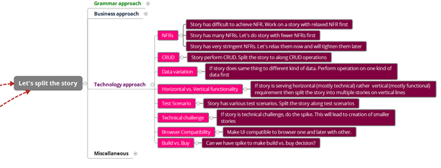

**Path 1 (NFRs):** A story might have many NFRs (non-functional requirements). Team may decide to focus on few NFRS now while leaving remaining for future. A story might also have many NFRs, team may decide to choose few and remaining for latter. Thirdly, team may decide to relax stringent NFRs for now and will come back to tighten them later. For example:

*As a user,*

*I want to see login page within one second of clicking submit button,*

*So that it can login faster.*

In this story, you have rightly spotted that NFR is very stringent which requires optimization across the board in the application. You may split this story into multiple stories. Each successive story tightening the NFRs in progressive fashion.

*As a user,*

*I want to see login page within five second of clicking submit button,*

*So that it can login faster.*

*As a user,*

*I want to see login page within two second of clicking submit button,*

*So that it can login faster.*

*As a user,*

*I want to see login page within one second of clicking submit button,*

*So that it can login faster.*

**Path 2 (CRUD):** A story might be performing all four create, read, update and delete operations. You can split this type of story into four or less stories focusing on a single or more operation/s.

*As an administrator,*

*I want to create, read, update, and delete users of the application,*

*So that I can manage app users.*

This story can be split in four stories but for brevity, here is split into three.

*As an administrator,*

*I want to create app users,*

*So that I can perform a part of user management.*

*As an administrator,*

*I want to see read and update app users,*

*So that I can perform a part of user management.*

*As an administrator,*

*I want to delete app users,*

*So that I can perform a part of user management.*

**Path 3 (Data Variation)**: Depending on data source or variation in data coming into application, you can split the story.

*As an administrator,*

*I want to store data coming from Facebook and Twitter to create prospects’ profile,*

*So that I can keep my prospects profile up to date.*

*As an administrator,*

*I want to store data coming from Facebook to create prospects’ profile,*

*So that I can keep my prospects profile up to date.*

*As an administrator,*

*I want to store data coming from Twitter to create prospects’ profile,*

*So that I can keep my prospects profile up to date.*

**Path 4 (Horizontal and Vertical split)**: Lot of tech people narrow down on layering of software which results in horizontal slicing of software along the lines. The common symptom of these type of story is “noting to demonstrate” by team for lot of stories as UI is still not developed. This type of stories results in technology silos. On the other hand, vertical stories cut through the technologies and focus on functionality.

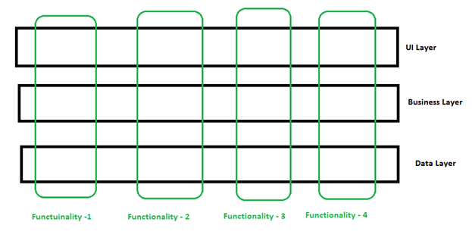

This technique is not for split but writing of stories along the functionalities.

**Path 5 (Test Scenarios):** If team is doing Story Test Driven Development (STDD), you can split the stories as per the tests.

*As a customer,*

*I want to pay my purchases using a credit card,*

*So that I enjoy my purchase.*

*This story has tests based on acceptance of credit cards from following networks:*

* *Visa Card*
* *Master Card*
* *American Express Card*
* *Discover Card*
* *Capital One*
* *JCB*
* *China UnionPay*
* *RuPay*

**Exercise**: Split the above story

**Path 6 (Tech Challenge):** Some stories might be technically difficult to implement. You may split this story along the challenges thrown by it. Some of the reasons of this challenge might be lack of skill, new technology; problem in hand is difficult, etc. Few challenging stories might turn into spike as well.

*As a marketing manager,*

*I want to find change in probability of purchasing our product by targeted prospects after running a campaign,*

*So that I can utilize marketing budget effectively.*

During the analysis of above story team realized that data about prospects is in Hadoop file system and one of the step-in algorithm is running Monte Carlo analysis. Team has never performed such kind of work especially performing Monte Carlo analysis in Hadoop file system. To overcome the technical challenge, team may decide to split above story into two stories and one spike.

*As a marketing manager,*

*I want to find change in probability of purchasing our product by targeted prospects after running a campaign (exclude Monte Carlo analysis from the algorithm),*

*So that I can utilize marketing budget effectively.*

*Spike: Run Monte Carlo analysis in Hadoop file system*

*As a marketing manager,*

*I want to find change in probability of purchasing our product by targeted prospects after running a campaign (include Monte Carlo analysis in the algorithm),*

*So that I can utilize marketing budget effectively.*

**Path 7 (Browser Compatibility):** In some cases, you may find that one of the requirement of your story is making it compatible to various browsers as well as various version of same browser. You may split a story based on different browsers and/or versions of same browser.

**Exercise**: Find a big story from your work area and split it

**Path 8 (Build vs. Buy):** In some cases, you may find that within a story you might have to make a build vs buy decision or help someone to make the decision. You may like to split the story on the lines of build vs buy line. This type of split is common in small organization.

**Miscellaneous approaches** to split a story

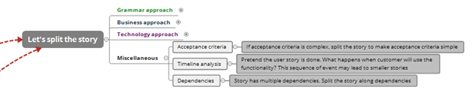

**Path 1 (Acceptance criteria):** A story might have a quite long list of acceptance criteria. To split a story, you may relax acceptance criteria a little and later on expand the list.

**Exercise**: Find a story with a lot of acceptance criteria from your work area and split it

**Path 2 (Time line analysis)**: A story might be a series of steps which are time dependent in software execution. To split such a story, you may consider some events initially and the add them using another story.

**Exercise**: Find a story which does action in present and then some other action in future from your work area and split it

**Path 3 (Dependencies)**: Especially in case of multiple teams, stories may have dependencies across teams. Even in case of a single team, stories might have dependencies. You may split such a story to reduce the dependency.

*As a user,*

*I want to update price information of items on sale,*

*So that I can items reflect correct prices at website.*

*Note: In this story data feed needed to update the prices is coming from suppliers*

*As a user,*

*I want to update price information of items on sale,*

*So that I can items reflect correct prices at website.*

*Note: Ignore the price related data feed from supplier*

*As a user,*

*I want to update price information of items on sale (use price data feed from suppliers),*

*So that I can items reflect correct prices at website.*

While splitting a story, you may follow some thumb rules:

* To split a story, choose grammar approach first and then business.
* Story splitting is a group exercise.
* Motives of story split are INVEST model, 3Cs and ensuring optimal size (1/6th to 1/10th of average velocity of team) of story.
* A story should be reaching to DONE state in couple of days by couple of DevTeam members.

**Reference**

1. <http://agileanswer.blogspot.com/2016/04/story-splitting-part-1-i-am-sure-youve.html>
2. <https://www.scaledagileframework.com/story>